**6-Program to implement Remote Procedure Call.**

A Remote Procedure Call (RPC) is a protocol that allows a program to execute a procedure (subroutine or method) on a remote server or another address space, as if it were a local procedure call, without the programmer explicitly coding the details of remote communication. RPC is a high-level, language-independent way to make distributed computing easy and efficient.

**C++ CODE**

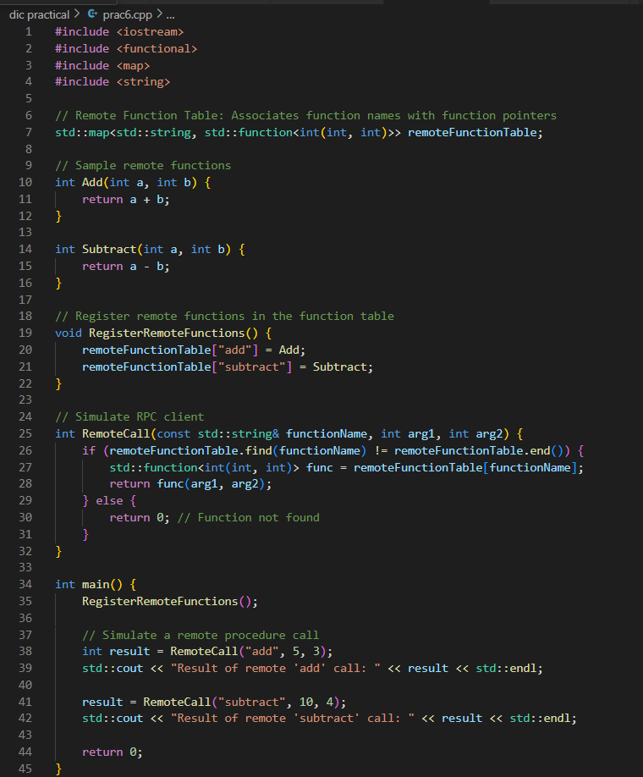

**OUTPUT:**

